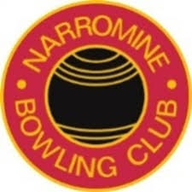
Club Secretaries – 1930 – 2020
Year – Terms |  | Name
1929-1930 |  | R.R. Armstrong
1931-1937 |  | W.R. Payten
1938-1942 |  | C.V. Butler
1943 |  | W.R. Payten
1944 |  | A.G.R. Cole
1945-1947 |  | J.M. Bayliss
1948-1950 |  | J.R. Radburn
1951 |  | W Lea
1951 |  | J.R. Matthews
1952-1954 |  | A.R. Mylechreest
1955-1958 |  | R.R. Barnett
1959-1963 |  | J.A. Hoffman
1963-1966 |  | K.J. Suters
1967-1971 |  | L.G. White
1972 |  | C Harbridge
1973 |  | A.F. Beutler
1974-1975 |  | D.N. Finlayson
1976 |  | J Green
1977-1985 |  | D.D. Mill
1986-1987 |  | B.C. Tipping
1988 |  | R.E. Cassidy
1989-1998 |  | K. Short
1999-2000 |  | R. Koerstz
2000-2007 |  | R. Schroder
2008-2010 |  | K. Short
2010-2011 |  | K. Rider
2011-2020 |  | N.R. Bohm

