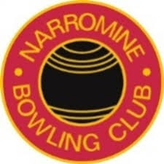
Life Members 1950 – 2020
Year |  | Name (# Denotes Deceased)
1950 |  | G.H.R. Barlow #
1950 |  | E. Barlow #
1950 |  | J. Scott #
1950 |  | A.C. Barlow #
1952 |  | P. McDermott #
1953 |  | J.E. Radburn #
1953 |  | E Lenehan #
1954 |  | J.P. Sibraa #
1954 |  | R.H. Barnett #
1959 |  | N.A. Lloyd #
1962 |  | R.D. Barnett #
1965 |  | R Heywood #
1966 |  | F Glass #
1967 |  | A Roberts #
1976 |  | J. Jones (snr) #
1977 |  | M. Elder #
1978 |  | C.S. Hawkins #
1986 |  | A.F. Beutler #
1987 |  | F. Wilkins #
1988 |  | D.N. Finlayson
1990 |  | C. Meijer #
1992 |  | R.G. Stanford #
1993 |  | D.D. Mills #
2008 |  | R. Koerstz
2008 |  | K. Short
2008 |  | R. Schroder
2015 |  | A.D. Lincoln
2015 |  | D. McNair

