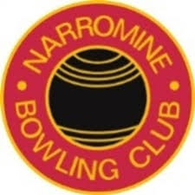
Club Presidents – 1930-Present
Years -Terms |  | Name
1930-1945 |  | G.M.R. Barlow
1945-1951 |  | R.M. (Bob) Barnett
1951-1953 |  | N.A. (Allan) lloyd
1953-1954 |  | Fred Ballhausen
1954 -1956 |  | N.A. (Allan) lloyd
1956-1960 |  | Ray Barnett
1960-1961 |  | H.J. Richardson
1961-1962 |  | E.R. (Paddy) Crawford
1963-1965 |  | Reg Heywood
1964-1968 |  | T.L Woods
1969-1972 |  | A.F (Fred) Beutler
1973-1975 |  | H.E.P. (Hughie) Olsen
1976-1978 |  | David Finlayson
1979-1980 |  | K.G. (keith) Hunt
1981-1983 |  | R.E. (ray) Cassidy
1984-1985 |  | J.R. (Jimmy) Jones
1986-1987 |  | David Finlayson
1988-1991 |  | Roger Koerstz
1992-1993 |  | Russell Schroder
1993-1998 |  | Roger Koerstz
1999-2003 |  | Kevin Short
2003-2004 |  | Roger Koerstz
2004-2008 |  | A.D. (des) Lincoln
2008-2011 |  | Roger Koerstz
2011- 2019 |  | Kevin Rider
2019-2020 |  | N.R. (Rick) Bohm# Resigned 01/08/2020
16/01/2021 |  | Daniel Carnevale

