The Robert Handsaker Ford Triples
Hosted By
Narromine Bowling Club
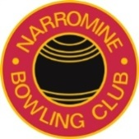
Saturday 03rd December : Sunday 04th December
$4000.00 Prizemoney#
Subject to Change if less than 24 Teams
5 Games 14 Ends
3 x 14 ends Saturday / 2 x 14 ends Sunday
Entry Fee $150.00 per team
(Includes Lunch Saturday – Snacks Sunday)
Entries limited to 24 Teams
Dress Code: Club Uniform – Creams
(Sponsored apparel may also be worn)
Play Commences 9.00am Both days
Open Draw in the Club-house at 8.30AM Saturday Morning
Nominations
Phone Club: (02) 68891164

